Internet and Web Programming

CSE3002

Fall Semester 2020-21

Lab Assignment 3

**ISHAAN OHRI**

**18BCE0265**

**Question:**

Write a program to demonstrate the concept of JavaScript DOM. Design an e- newspaper using DOM with following feature:

i. Add buttons to change the headlines, content and author with respect to the date.

ii. Customize the advertisements page based on the requirement

Validate the form for empty field submissions.

**Procedure:**

<!DOCTYPE html>: Tells browser that it is an HTML document

<head>: Container for header elements

<title>: Name for toolbar

<body>: Body element for document

<style>: Styles for the different elements

<h1>: Heading of level 1

align: alignment on the HTML document

<p>: Defines a paragraph

<img>: Inserts image

<button>: Defines a clickable button

<script>: Used to embed a client-side script (JavaScript)

background-color: Defines the background colour of the element

font-size: Defines the font size of the enclosed font

text-align: Defines the alignment of the text

font-family: Defines the font of the text

font-style: Defines the style of font like bold, italic etc.

padding-left: Defines the left padding

padding-right: Defines the right padding

color: Defines colour of text

**Code:**

**index.html**

<!DOCTYPE html>

<html lang="en">

<head>

<meta charset="UTF-8">

<meta name="viewport" content="width=device-width, initial-scale=1.0">

<title>E-Newspaper</title>

<meta charset="utf-8">

<meta name="viewport" content="width=device-width, initial-scale=1">

<link rel="stylesheet" href="//code.jquery.com/ui/1.12.1/themes/base/jquery-ui.css">

<link rel="stylesheet" href="./style.css">

<script src="https://code.jquery.com/jquery-1.12.4.js"></script>

<script src="https://code.jquery.com/ui/1.12.1/jquery-ui.js"></script>

<script src="./main.js"></script>

</head>

<body>

<h1 align="center">Times of India</h2>

<hr>

<br>

<span>

<div id="left">

<img id="ad-left" height="1000px" width="200px" src="./ad1.gif">

<br>

<button id="change-left" onclick="changeLeft()">Change Ad</button>

</div>

<div id="news">

<p>Date: <input type="text" id="datepicker"></p>

<br>

<h2 id="heading-1">Eight assembly seats vacant in Uttar Pradesh, EC to decide on bypolls</h2>

<img id="img-1" width="500px" src="news1.jpg">

<p id="content-1">Uttar Pradesh may witness a mini-assembly election of sorts in the coming months if the Election Commission (EC) decides to hold bypolls to eight vacant seats in the state assembly along with the Bihar elections. Five of these eight seats fell vacant after the death of sitting members. “The Election Commission of India has to take a call about holding by-polls to the eight assembly seats. As of now, we have no information about the possible timing of the bypolls,” said a senior officer. A bypoll to a vacant seat in the state assembly is generally held within six months from the date of vacancy. However, EC has not yet given any indication about holding these bypolls. “For seats, where the six-month time period is complete, EC has given a certificate, saying a decision about holding the bypoll there will be taken later,” said the officer.</p>

<br>

<h2 id="heading-2">WHO’s global COVAX plan: All you need to know about Covid-19 vaccine access plan</h2>

<img id="img-2" width="500px" src="news2.jpg">

<p id="content-2">The World Health Organization (WHO) on Monday said some 172 countries are engaging with the COVAX facility designed to ensure equitable access to Covid-19 vaccines, but more funding is needed and countries need to make binding commitments. The WHO had earlier urged countries to join a global pact aimed at ensuring less wealthy countries have access to Covid-19 vaccines, warning about the risks from so-called ‘vaccine nationalism.’ WHO director general Tedros Adhanom Ghebreyesus has said initially, when there will be limited supply of Covid-19 vaccines, it’s important to provide the vaccine to those at highest risk around the globe. He said this included health workers on the front lines of the pandemic, who were “critical to saving lives and stabilising the overall health system”.</p>

</div>

<div id="right">

<img id="ad-right" height=1000px width="200px" src="./ad3.png">

<br>

<button id="change-right" onclick="changeRight()">Change Ad</button>

</div>

</span>

</body>

</html>

**style.css**

#news{

width: 1000px;

margin: 0 auto;

padding-left: 15%;

padding-right: 20%;

display: inline-block;

}

#left{

display: inline-block;

}

#right{

display: inline-block;

}

#change-left{

background-color: brown;

color: white;

margin-left: 20%;

font-size: medium;

}

#change-right{

background-color: brown;

color: white;

margin-left: 20%;

font-size: medium;

}

**script.js**

$( function() {

$( "#datepicker" ).datepicker({

onSelect : function(date){

var day = date.substr(3,2);

if(day == 24){

document.getElementById('heading-1').innerHTML="69,239 Covid Cases In India In 24 hours, Over 30 Lakh Total Cases";

document.getElementById('content-1').innerHTML="India recorded single-day jump of 69,239 coronavirus cases in the last 24 hours, taking the tally to 30,44,940 cases, the Union Health Ministry said this morning. About 22,80,566 lakh people have recovered. 56,706 Covid-linked deaths have been registered so far; 912 patients have died since yesterday, according to the official data. The recovery rate stood at 74.89 per cent this morning. India is behind Brazil and the US in the number of cases in the world.";

document.getElementById('img-1').src = './news3.jpg';

document.getElementById('heading-2').innerHTML="Residents Moved Out After Gurgaon Building Tilts Due To Heavy Rain";

document.getElementById('content-2').innerHTML="The residents of a four-storey house in Gurgaon have been moved out after the building tilted following heavy rain. The building in Sector 46 has been vacated, the police told news agency ANI. Gurgaon near Delhi, the Millennium City with multiple malls, high-rises and offices of multinational companies, has been severely challenged in two days of heavy downpour. The area where the building is located was severely flooded after yesterday's downpour, according to the police. Haryana: Police vacated a four-storey building in Gurugram's Sector-46 after it bent on one side, following heavy downpour in the region.";

document.getElementById('img-2').src = './news4.jpg';

}else if(day == 25){

document.getElementById('heading-1').innerHTML="Eight assembly seats vacant in Uttar Pradesh, EC to decide on bypolls";

document.getElementById('content-1').innerHTML="Uttar Pradesh may witness a mini-assembly election of sorts in the coming months if the Election Commission (EC) decides to hold bypolls to eight vacant seats in the state assembly along with the Bihar elections. Five of these eight seats fell vacant after the death of sitting members. “The Election Commission of India has to take a call about holding by-polls to the eight assembly seats. As of now, we have no information about the possible timing of the bypolls,” said a senior officer. A bypoll to a vacant seat in the state assembly is generally held within six months from the date of vacancy. However, EC has not yet given any indication about holding these bypolls. “For seats, where the six-month time period is complete, EC has given a certificate, saying a decision about holding the bypoll there will be taken later,” said the officer.";

document.getElementById('img-1').src = './news1.jpg';

document.getElementById('heading-2').innerHTML="WHO’s global COVAX plan: All you need to know about Covid-19 vaccine access plan";

document.getElementById('content-2').innerHTML="The World Health Organization (WHO) on Monday said some 172 countries are engaging with the COVAX facility designed to ensure equitable access to Covid-19 vaccines, but more funding is needed and countries need to make binding commitments. The WHO had earlier urged countries to join a global pact aimed at ensuring less wealthy countries have access to Covid-19 vaccines, warning about the risks from so-called ‘vaccine nationalism.’ WHO director general Tedros Adhanom Ghebreyesus has said initially, when there will be limited supply of Covid-19 vaccines, it’s important to provide the vaccine to those at highest risk around the globe. He said this included health workers on the front lines of the pandemic, who were “critical to saving lives and stabilising the overall health system”.";

document.getElementById('img-2').src = './news2.jpg';

}else{

alert('Select a valid date');

}

}

});

}

);

function changeLeft(){

if(document.getElementById('ad-left').src.includes('ad1')){

document.getElementById('ad-left').src = './ad2.gif'

}else{

document.getElementById('ad-left').src = './ad1.gif'

}

}

function changeRight(){

if(document.getElementById('ad-right').src.includes('ad3')){

document.getElementById('ad-right').src = './ad4.gif'

}else{

document.getElementById('ad-right').src = './ad3.png'

}

}

**Output:**

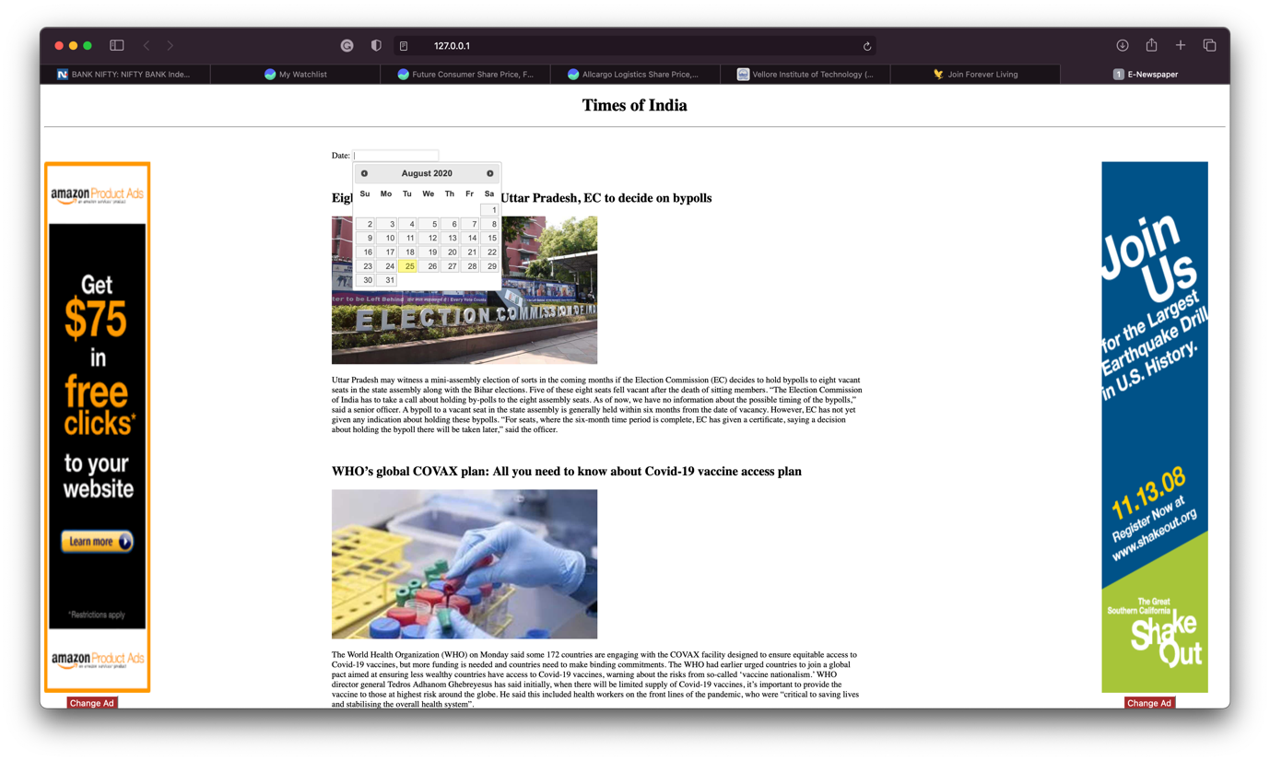

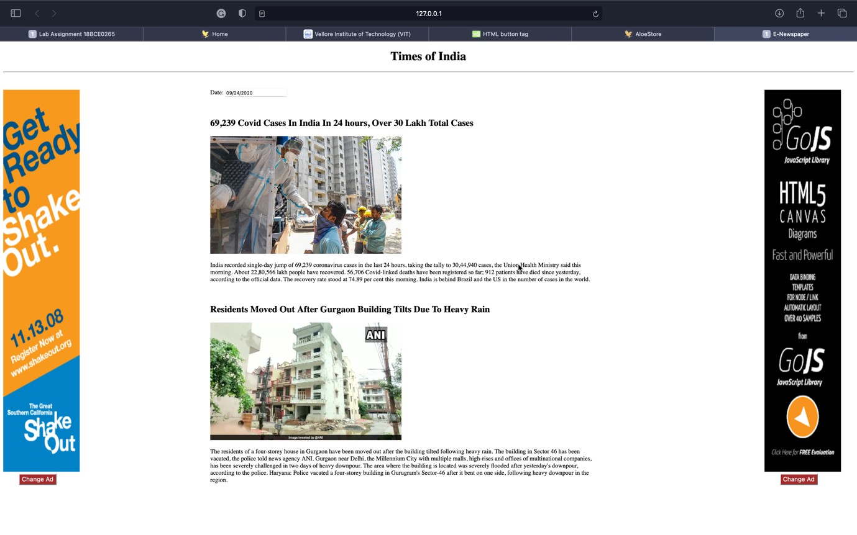

**Question:**

Write a program to demonstrate the concept of JQuery.

1. Create three buttons with labels red, green, blue, when the mouse is moved over it, the background color has to be changed respectively.
2. Create a HTML page holding a list of items and an [Extract Text] button. Implement the extractText function which will be called when the button's onClick event is fired.
3. Create a HTML page that holds a list of towns, a search box and a [Search] button. Implement the search function to bold the items from the list which include the text from the search box.
4. Disable/enable the form submit button. Disable the submit button until the visitor has clicked a check box.
5. Distinguish between left and right mouse click.
6. Remove style added with .css() function.

**Procedure:**

<!DOCTYPE html>: Tells browser that it is an HTML document

<head>: Container for header elements

<title>: Name for toolbar

<body>: Body element for document

<style>: Styles for the different elements

<h1>: Heading of level 1

align: alignment on the HTML document

<p>: Defines a paragraph

<img>: Inserts image

<button>: Defines a clickable button

<ul>: An unordered list starts with <ul>

<li>: Each list item starts with <li>

<input>: Declare input controls that allow users to input data.

type: Defines the type of input text/radio/checkbox

name: Defines the name of the <input> element

id: Unique id to identify

pattern: Defines pattern of input data

required: Compulsory to enter

value: Defines the value of the option in radio/checkbox

<script>: Used to embed a client-side script (JavaScript)

background-color: Defines the background colour of the element

font-size: Defines the font size of the enclosed font

text-align: Defines the alignment of the text

font-family: Defines the font of the text

font-style: Defines the style of font like bold, italic etc.

padding-left: Defines the left padding

padding-right: Defines the right padding

color: Defines colour of text

**Code:**

**index.html**

<!DOCTYPE html>

<html lang="en">

<head>

<meta charset="UTF-8">

<meta name="viewport" content="width=device-width, initial-scale=1.0">

<title>Lab Assignment 18BCE0265</title>

<link rel="stylesheet" type="text/css" href="style.css">

<link rel="stylesheet" type="text/css" href="https://stackpath.bootstrapcdn.com/ bootstrap/4.5.2/css/bootstrap.min.css">

<script src="https://code.jquery.com/jquery-3.5.1.js" integrity="sha256- QWo7LDvxbWT2tbbQ97B53yJnYU3WhH/C8ycbRAkjPDc=" crossorigin="anonymous"></script>

</head>

<body>

<div class="container-button">

<button id="red-button">RED</button>

<button id="green-button">GREEN</button>

<button id="blue-button">BLUE</button>

</div>

<div class="container-extract-text">

<p id="extract">This text will be extracted in the text field!</p>

<br>

<button id="extract-text">Extract Text</button>

<br>

<p id="text">Click the button to extract text from list</p>

</div>

<div class="container-search">

<ul id="cities">

<li>Delhi</li>

<li>Mumbai</li>

<li>Chennai</li>

<li>Bangalore</li>

<li>Hyderabad</li>

<li>Kolkata</li>

</ul>

<br>

<input type="text" id="search-field" placeholder="Search" required>

<button id="search-button">Search</button>

<br>

</div>

<div class="container-submit">

<input type="checkbox" id="check">

<button id="submit-button">Submit</button>

</div>

<div class="container-mouse">

<p>Use this area to detect mouse click</p>

</div>

<div class="container-css">

<p id="css-text">I am ISHAAN OHRI. My Reg. No. 18BCE0265<p>

<div class="but">

<button id="add-css" >Add</button>

<button id="remove-css" >Remove</button>

</div>

</div>

</body>

<script src="app.js"></script>

</html>

**style.css**

#red-button{

background-color: white;

color: red;

font-size: x-large;

padding-right: 30px;

padding-left: 30px;

padding-top: 10px;

padding-bottom: 10px;

border-style: solid;

border-width: 2px;

border-color: black;

border-radius: 5px;

}

#green-button{

background-color: white;

color: green;

font-size: x-large;

padding-right: 30px;

padding-left: 30px;

padding-top: 10px;

padding-bottom: 10px;

border-style: solid;

border-width: 2px;

border-color: black;

border-radius: 5px;

}

#blue-button{

background-color: white;

color: blue;

font-size: x-large;

padding-right: 30px;

padding-left: 30px;

padding-top: 10px;

padding-bottom: 10px;

border-style: solid;

border-width: 2px;

border-color: black;

border-radius: 5px;

}

#extract-text{

background-color: white;

color: deepskyblue;

font-size: x-large;

padding-right: 30px;

padding-left: 30px;

padding-top: 10px;

padding-bottom: 10px;

border-style: solid;

border-width: 2px;

border-color: white;

border-radius: 5px;

}

#search-button{

height: 50px;

width: 150px;

color: mediumvioletred;

background-color: white;

font-size: x-large;

padding-right: 30px;

padding-left: 30px;

padding-top: 10px;

padding-bottom: 10px;

border-style: solid;

border-width: 2px;

border-color: white;

border-radius: 5px;

}

#submit-button{

height: 50px;

width: 150px;

background-color: white;

font-size: x-large;

padding-right: 30px;

padding-left: 30px;

padding-top: 10px;

padding-bottom: 10px;

border-style: solid;

border-width: 2px;

border-color: white;

border-radius: 5px;

}

.container-extract-text{

height: 500px;

width: 100%;

background-color: deepskyblue;

display: flex;

justify-content: center;

justify-content: space-around;

align-items: center;

}

.container-button{

height: 500px;

width: 100%;

display: flex;

justify-content: center;

justify-content: space-around;

align-items: center;

}

.container-search{

height: 500px;

width: 100%;

background-color: mediumvioletred;

display: flex;

justify-content: center;

justify-content: space-around;

align-items: center;

}

.container-submit{

height: 500px;

width: 100%;

background-color: violet;

display: flex;

justify-content: center;

justify-content: space-around;

align-items: center;

}

.container-mouse{

height: 500px;

width: 100%;

background-color: coral;

display: flex;

justify-content: center;

justify-content: space-around;

align-items: center;

}

.container-css{

height: 500px;

width: 100%;

background-color: limegreen;

display: flex;

justify-content: center;

justify-content: space-around;

align-items: center;

}

#cities{

font-size: xx-large;

font-family: Verdana, Geneva, Tahoma, sans-serif;

list-style: none;

color:white;

}

p{

font-size: x-large;

font-family: Verdana, Geneva, Tahoma, sans-serif;

list-style: none;

color:white;

}

#check{

height: 150px;

width: 150px;

}

#add-css,

#remove-css{

height: 50px;

width: 150px;

background-color: white;

color: limegreen;

font-size: x-large;

padding-right: 30px;

padding-left: 30px;

padding-top: 10px;

padding-bottom: 10px;

border-style: solid;

border-width: 2px;

border-color: white;

border-radius: 5px;

}

.test{

font-size:50px;

color: darkmagenta;

font-weight: bolder;

}

#search-field{

height: auto;

width: auto;

font-size: x-large;

padding-right: 30px;

padding-left: 30px;

padding-top: 10px;

padding-bottom: 10px;

border-style: solid;

border-width: 2px;

border-color: white;

border-radius: 5px;

}

**script.js**

$(document).ready(function(){

$('#red-button')

.mouseover(function(){

$('.container-button').css('background-color','red')

})

.mouseout(function(){

$('.container-button').css('background-color', 'white')

})

$('#blue-button')

.mouseover(function(){

$('.container-button').css('background-color','blue')

})

.mouseout(function(){

$('.container-button').css('background-color', 'white')

})

$('#green-button')

.mouseover(function(){

$('.container-button').css('background-color','green')

})

.mouseout(function(){

$('.container-button').css('background-color', 'white')

})

$('#extract-text').click(function(){

$('#text').text($('#extract').text())

})

$('#check').click(function(){

if($('#check')[0].checked){

$('#submit-button').prop('disabled', false);

}else{

$('#submit-button').prop('disabled', true);

}

})

$('.container-mouse').click(function(event){

if(event.button == 0){

alert('Left Click')

}

else if(event.button == 2){

alert('Right Click')

}

})

$('#add-css').click(function(){

$('#css-text').addClass("test")

})

$('#remove-css').click(function(){

$('#css-text').removeClass("test")

})

$('#search-button').click(function(){

$('#cities li').each(function(i, li){

const city = $(li);

city.css('font-weight', 'lighter')

})

const search = $('#search-field').val()

if(search.length == 0){

alert('Empty text field')

}else{

$('#cities li').each(function(i, li){

const city = $(li);

if(city[0].innerText.includes(search)){

city.css('font-weight', 'bolder')

}

})

}

})

})

**Output:**

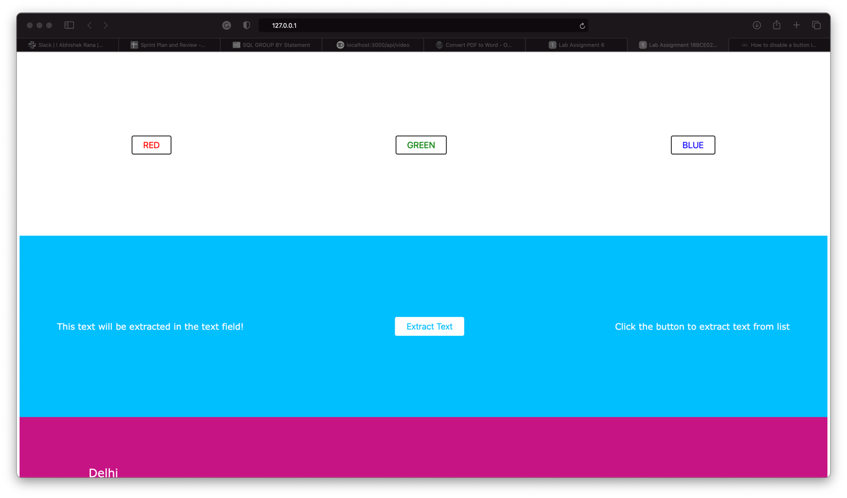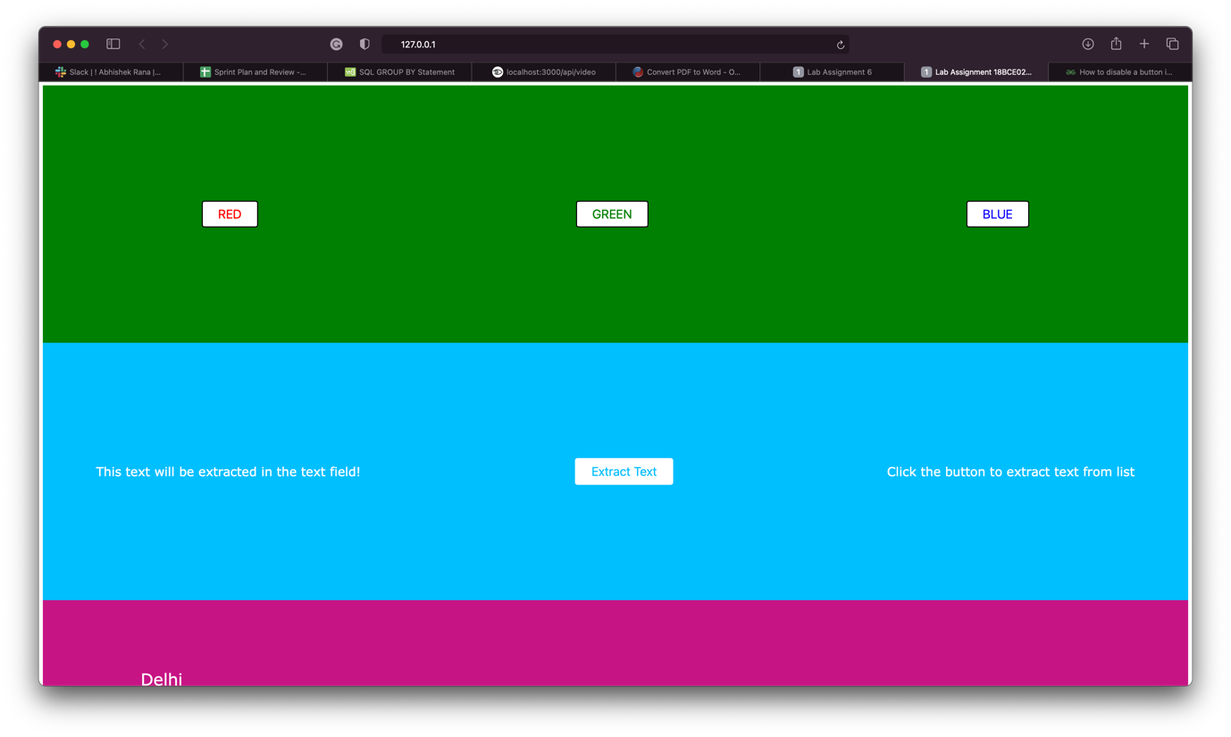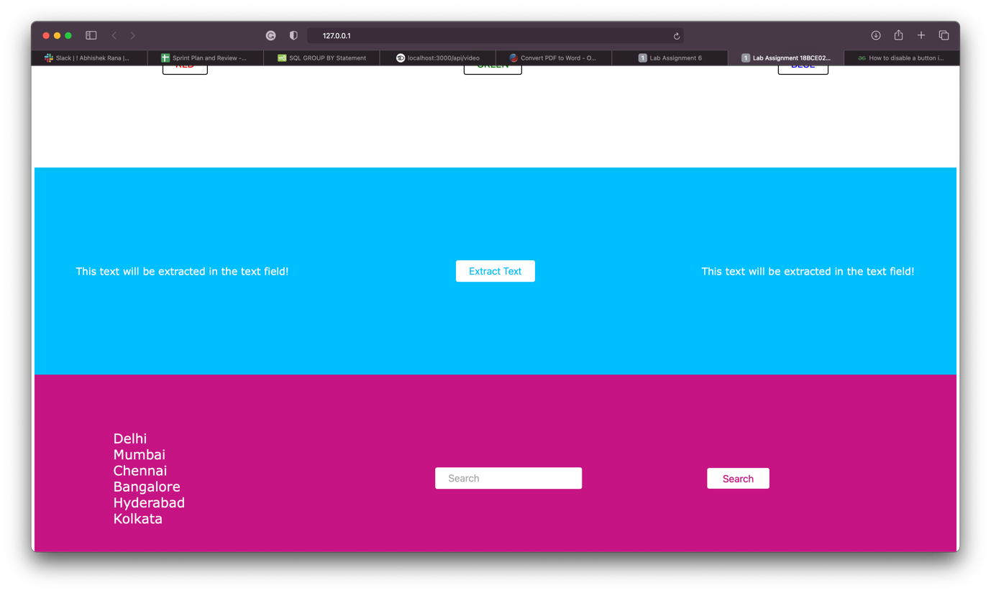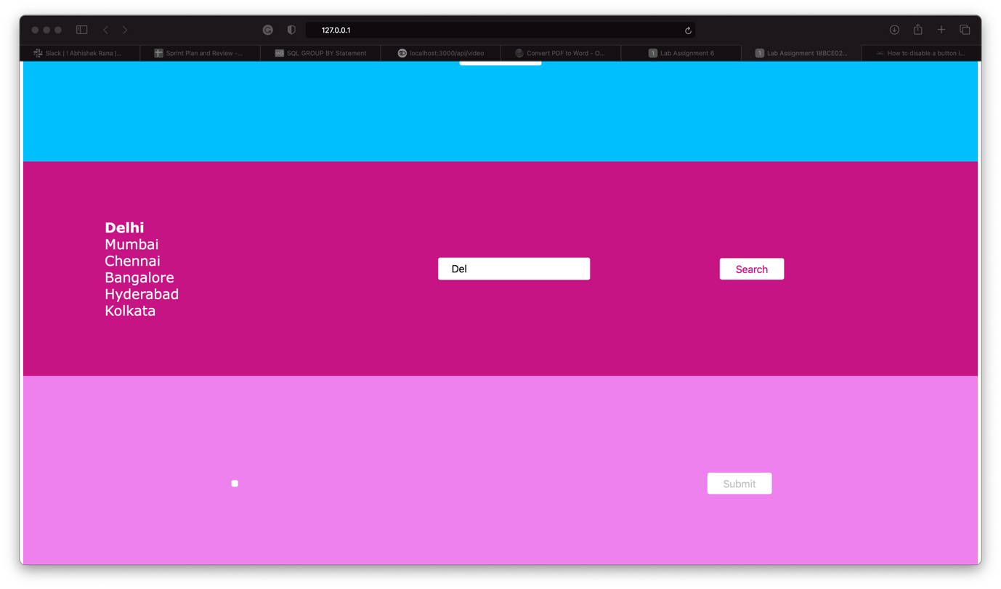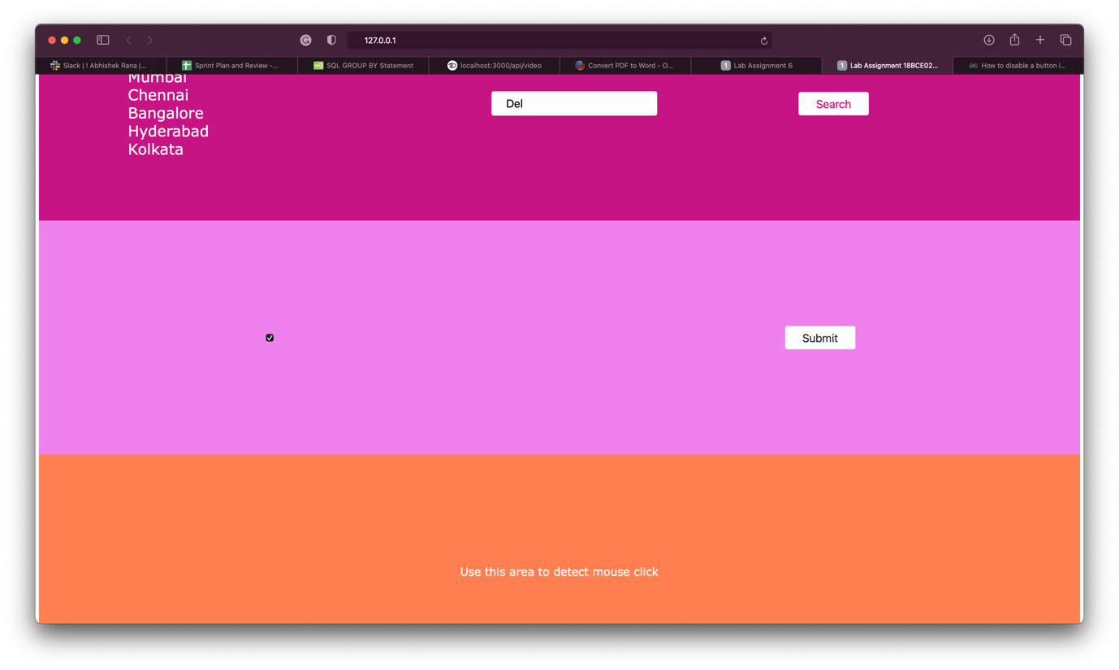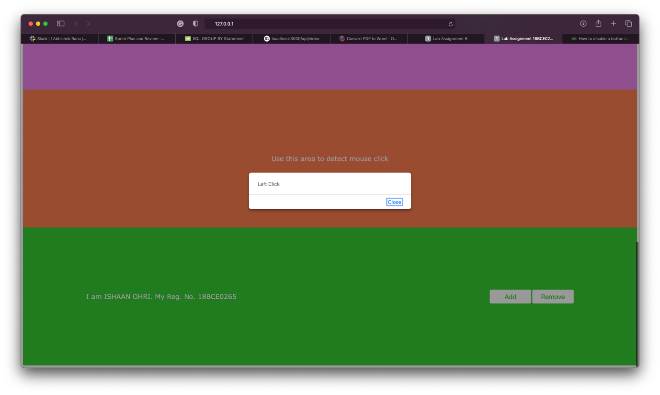

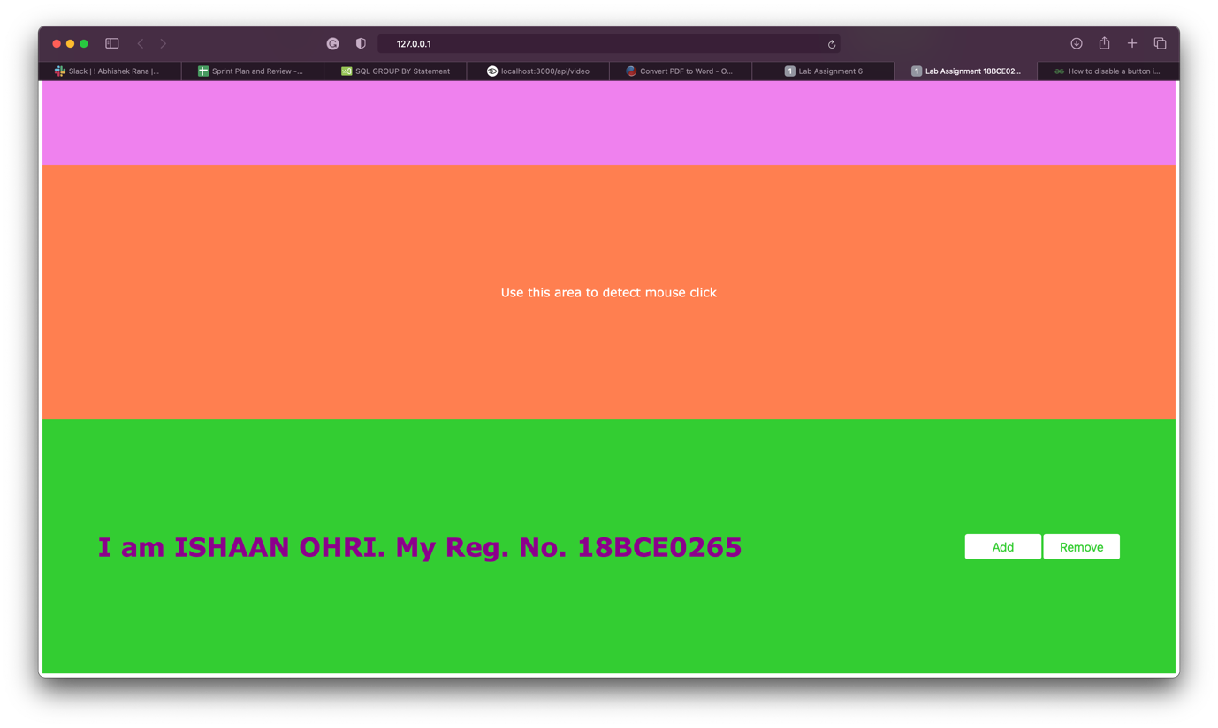

**Question:**

A Jobseeker submits his Resume and Photograph to a online job portal. The portal accepts the submission of files only after the key validations. Write the appropriate HTMLcontaining (Input types and button) and PHP script to process the files based on the following

* Specifies the directory where the files are going to be placed
* Check if File Name Already Exists
* The Resume should accept only Pdf / Doc and size of the file must be within 500kb
* Allowed file types for the photograph(jpeg, jpg) and file size within 1 mb
* Checks whether a file was uploaded via HTTP POST

**Procedure:**

<!DOCTYPE html>: Tells browser that it is an HTML document

<body>: Body element for document

<form>: Creates an HTML form for user input

action: backend script to process data

method: API request method

<h1>: Heading of level 1

align: alignment on the HTML document

<input>: Declare input controls that allow users to input data.

type: Defines the type of input text/radio/checkbox

name: Defines the name of the <input> element

id: Unique id to identify

pattern: Defines pattern of input data

required: Compulsory to enter

value: Defines the value of the option in radio/checkbox

**Code:**

**index.html**

<!DOCTYPE html>

<html>

<body>

<h1 style ='font:40px Arial; color:#ff0000'>ISHAAN OHRI 18BCE0265 Assignment 8-A</h1>

<form action="upload.php" method="post" enctype="multipart/form-data">

Select file to upload (.docx/.pdf):

<br>

<input type="file" name="fileToUpload" id="fileToUpload" />

<br>

<br>

Select image to upload (.jpeg/.jpg):

<br>

<input type="file" name="imageToUpload" id="imageToUpload" />

<br>

<br>

<input type="submit" value="Upload" name="submit" />

</form>

</body>

</html>

**upload.html**

<?php

$target_dir_file = "uploads/";

$target_dir_image = "images/";

$target_file = $target_dir_file.basename($_FILES["fileToUpload"]["name"]);

$target_image = $target_dir_image.basename($_FILES["imageToUpload"]["name"]);

$uploadOk_file = 1;

$uploadOk_image = 1;

if (file_exists($target_file))

{

echo "Oops! The resume file already exists.<br>";

$uploadOk_file = 0;

}

if (file_exists($target_image))

{

echo "Oops! The image file already exists.<br>";

$uploadOk_image = 0;

}

if (($_FILES["fileToUpload"]["size"] > 500000)) {

echo "Oops! The resume file is too large.<br>";

$uploadOk_file = 0;

}

if(($_FILES["imageToUpload"]["size"] > 500000 * 2 + 24000))

{

echo "Oops! The image file is too large.<br>";

$uploadOk_image = 0;

}

$FileType = strtolower(pathinfo($target_file,PATHINFO_EXTENSION));

$imageFileType = strtolower(pathinfo($target_image,PATHINFO_EXTENSION));

if(isset($_POST["submit"])) {

if($FileType != "docx" && $FileType != "pdf")

{

echo "Oops! The resume file should only be .PDF or .DOCX.<br>";

$uploadOk_file = 0;

}

if($imageFileType != "jpg" && $imageFileType != "jpeg") {

echo "Oops! The image file should only be .JPG or .JPEG.<br>";

$uploadOk_image = 0;

}

}

if(is_uploaded_file($target_file)) {

echo ("$target_file is uploaded via HTTP POST<br>");

} else {

echo ("$target_file is not uploaded via HTTP POST<br>");

}

if(is_uploaded_file($target_image)) {

echo ("$target_image is uploaded via HTTP POST<br>");

} else {

echo ("$target_image is not uploaded via HTTP POST<br>");

}

if ($uploadOk_file == 0) {

echo "Oops! The resume file was not uploaded.<br>";

} else {

if (move_uploaded_file($_FILES["fileToUpload"]["tmp_name"], $target_file)) {

echo "The file ". basename( $_FILES["fileToUpload"]["name"]). " has been uploaded.<br>";

} else {

echo "Oops! The image file was not uploaded.<br>";

}

}

if ($uploadOk_image == 0) {

echo "Oops! The image file was not uploaded.<br>";

} else {

if (move_uploaded_file($_FILES["imageToUpload"]["tmp_name"], $target_image)) {

echo "The image ". basename( $_FILES["imageToUpload"]["name"]). " has been uploaded.<br>";

} else {

echo "Oops! The resume file was not uploaded.<br>";

}

}

?>

**Output:**

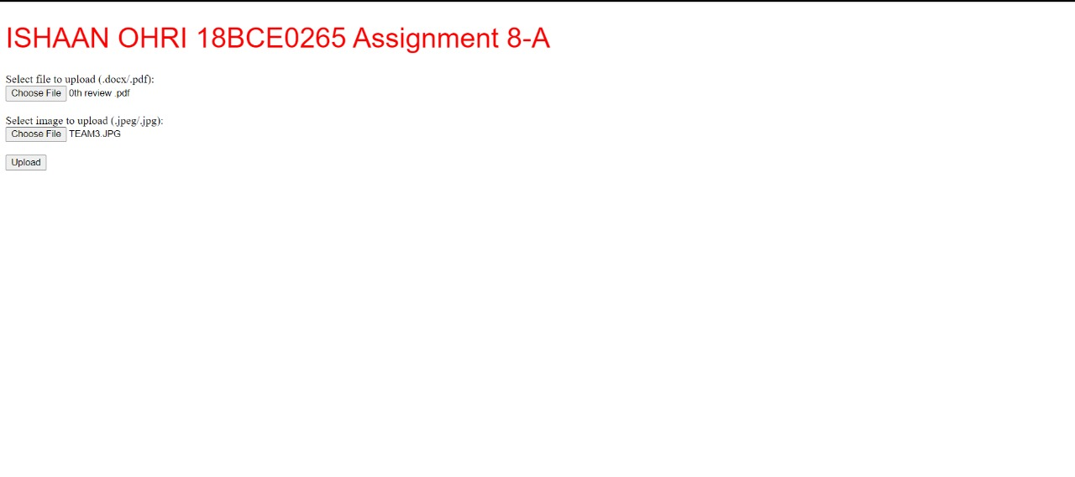

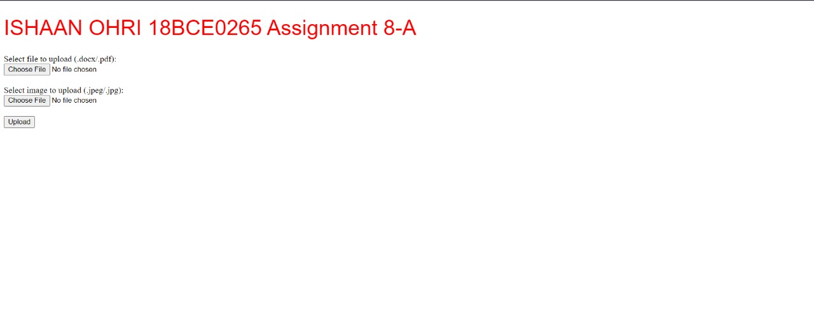

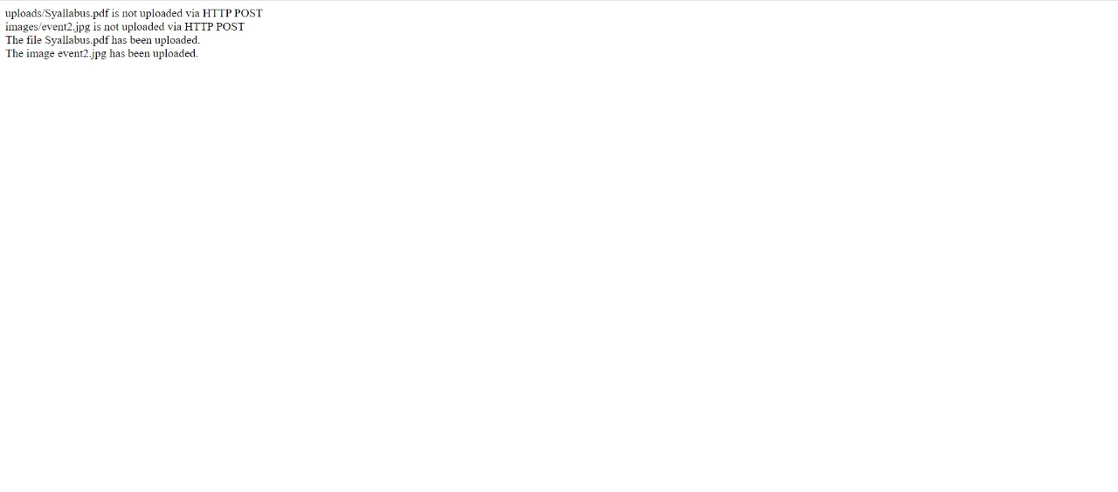



**Question:**

Write a PHP program to write 100 integers in to a text file. Read 10 numbers at a time from the file using PHP script and find the numbers which occurs odd number of times.

Input : 4, 5, 4, 5, 2, 2, 3, 3, 2, 4 Output : 2, 4

**Code:**

**index.php**

<?php

echo "<h1 style ='font:40px Arial; color:#ff0000'>ISHAAN OHRI 18BCE0265 Assignment 8-B</h1>";

// For writing the file

$numfile = fopen("file.txt", "w") or die("Unable to open file!");

for ($i = 0; $i < 10; $i++) {

for ($j = 0; $j < 10; $j++) {

$num = rand(1, 5);

fwrite($numfile, $num . " ");

}

fwrite($numfile, "\n");

}

fclose($numfile);

// For reading the file

$numfile = fopen("file.txt", "r") or die("Unable to open file!");

for ($i = 0; $i < 10; $i++) {

$line = fgets($numfile);

$arr = explode (" ", $line);

$arr = array_slice($arr,0,10);

echo "<strong style ='font:20px Arial; color:#000000'>Input : </strong>";

for ($j = 0; $j < 10; $j++) {

echo $arr[$j] . " ";

}

echo '<br>';

$uarr = array_unique($arr);

echo "<strong style ='font:20px Arial; color:#000000'>Output : </strong>";

foreach ($uarr as $el) {

$count = 0;

for ($j = 0; $j < 10; $j++) {

if ($el == $arr[$j]) {

$count++;

}

}

if ($count % 2 != 0)

echo $el . " ";

}

echo '<br>';

echo '<br>';

}

fclose($numfile);

?>

**Output:**

